1

INTRODUCTION

1. **INTRODUCTION**

* The **Online Bookstore System** is a simple and efficient software solution designed to manage and sell books through a digital platform.
* It provides a smooth experience for both **admin** and **customers**, allowing them to interact through one centralized system.

* The system allows the **admin** to add, update, and manage book listings, including details like book title, author, category, price, description, and book cover images.
* This makes it easier to organize and maintain the entire book collection.
* Users can easily browse through all available books and use powerful **search and filter options**, such as category, author, and price range, to quickly find the books they need.
* The system ensures a fast, simple, and user-friendly book selection experience.
* Customers can view book details, add items to the cart, place orders, and track their purchases through the user panel.
* The system also includes features for handling inquiries, order management.
* The **admin panel** helps the administrator manage books, orders, users, and categories, improving overall efficiency and reducing manual work.
* By automating these processes, the Online Bookstore System reduces errors, saves time, and improves both store management and customer satisfaction.
* This project aims to offer a **secure, reliable, and easy-to-use platform** for buying and managing books online, suitable for both small bookstores and large digital book-selling businesses.

2.

**Proposed System**

**2.1 Scope**

1. **Book Management**

* Admin can add, update, or remove books from the system.
* Details like title, author, category, price, description, and images can be managed easily.

1. **User-Friendly Browsing**

* Customers can search and filter books by category, author, or price.
* Helps users quickly find the books they want.

1. **Shopping and Orders**

* Users can view book details, add books to cart, and place orders online.
* Customers can track their orders from the system.

1. **Admin Control Panel**

* Admin can manage books, users, categories, group, city, feedback and orders in one place.
* Makes store management fast and organized.

1. **Automation and Efficiency**

* Reduces manual work and errors by automating tasks.
* Saves time and improves customer satisfaction.

1. **Scalability**

* Can be used by small bookstores or large online book stores.
* Secure and reliable for handling multiple users and orders.

1. **Customer Support**

* System can handle inquiries or messages from customers efficiently.

**2.2 Objectives**

1. **Simplify Book Management for Admin**

* Allow the admin to easily add, update, or delete books.
* Manage all book details like title, author, category, price, description, and images from one place.
* Reduce manual work and errors in maintaining the book collection.

1. **Provide a Smooth Shopping Experience for Customers**

* Let users browse books easily with search and filter options.
* Customers can view book details, add books to cart, and place orders online.
* Enable customers to track their orders and manage their account.

1. **Improve Efficiency and Automation**

* Automate repetitive tasks like order processing and inventory management.
* Save time for both admin and customers.
* Reduce mistakes caused by manual handling.

1. **Enhance Customer Satisfaction**

* Offer a fast, secure, and user-friendly platform.
* Make it easy to find, order, and receive books.
* Handle customer inquiries efficiently.

1. **Support Business Growth**

* Suitable for small bookstores and large online book stores.
* Allow scalability for adding more books, users, and categories.
* Enable admins to manage the store more effectively as it grows.

**2.3 Constraints**

**2.3.1 H/W (Hardware) Constraints**

Hardware constraints refer to the physical components of the system that limit how the software can run efficiently. For the Online Bookstore System, the possible hardware constraints are:

1. **Server Requirements**

* The server hosting the system must have enough storage and memory to handle book data, images, and user requests.
* Example: Minimum 8 GB RAM and 500 GB storage for smooth performance.

1. **Client Device Requirements**

* Users (customers/admin) should access the system from devices that support modern web browsers.
* Example: Desktop, laptop with a stable internet connection.

1. **Processing Power**

* Both server and client devices should have sufficient CPU performance to process requests quickly.
* If the hardware is weak, the system may be slow or unresponsive.

1. **Network Dependency**

* The system requires a stable internet connection for real-time access, searching books, and placing orders.
* Poor network speed can affect system performance and user experience.

**2.3.2 S/W (Software) Constraints**

Software constraints refer to the limitations imposed by the software environment needed to run the system. For the Online Bookstore System, the constraints are:

1. **Operating System Compatibility**

* The system must run on servers with supported OS like Windows Server or Linux.
* Client devices should support browsers like Chrome, Firefox, Edge, or Safari.

1. **Database Requirements**

* The system relies on a database (like SQL Server, MySQL, or PostgreSQL) to store book and user data.
* Database size, structure, and query efficiency can limit system performance if not properly managed.

1. **Browser Compatibility**

* Web application must be tested to work correctly on all modern browsers.
* Older browsers may not support some features like responsive design or dynamic scripts.

1. **Security Software**

* Proper firewall and antivirus software are needed to prevent unauthorized access.
* Security constraints may limit some system actions to protect sensitive data (like user credentials and payment info).

1. **Software Dependencies**

* The system may require additional software or frameworks like .NET, Angular, or PHP depending on the technology used.
* Incompatibility or missing dependencies can prevent the system from running properly.

**2.4 Advantages**

1. **Easy Book Management**

* Admin can add, update, or remove books quickly without manual record-keeping.
* Reduces errors in maintaining the book collection.

1. **Convenient for Customers**

* Users can search, filter, and browse books easily.
* Books can be purchased from anywhere, anytime using the web.

1. **Time-Saving and Efficient**

* Automation of order processing and inventory management saves time for both admin and customers.
* Reduces repetitive manual tasks.

1. **Enhanced Customer Satisfaction**

* Fast, secure, and user-friendly platform ensures a smooth shopping experience.
* Features like cart, order tracking, and home delivery improve convenience.

1. **Scalable and Flexible**

* Can be used by small bookstores or large online shops.
* Supports adding new books, users, and categories easily.

1. **Better Business Control**

* Admin panel allows managing books, users, orders, categories, groups, cities, and feedback in one place.
* Helps in better reporting, auditing, and store management.

1. **Customer Support and Communication**

* Handles customer inquiries and feedback efficiently.
* Email notifications and order updates improve communication.

**2.5 Limitations**

1. **Internet Dependency**

* System requires a stable internet connection to access and use.
* Poor connectivity may slow down or prevent access.

1. **Initial Setup Cost**

* Setting up the system may require hardware, software, and server costs.

1. **Technical Knowledge Required**

* Admin needs basic computer and software knowledge to manage the system efficiently.

1. **Browser and Device Compatibility**

* Some older browsers or devices may not support all features properly.

1. **Limited Offline Functionality**

* Cannot perform tasks like order placement or inventory management without internet.

1. **Security Risks**

* As with any online system, there is a risk of hacking or data breaches if security measures are weak.

**2.6 Project Modules**

**ADMIN:**

* **Login:** The login module is designed for the admin. Only authorized admin users can access the admin panel. Admin can log in to the Online Book Store Management System using their registered credentials.
* **Dashboard:** In this section, the admin can view the overall system summary including:
  + User management
  + Book management
  + Category management
  + City management
  + Order management
  + Payment overview
  + Feedback overview
* **Book Management:** In this section, the admin can add, update, delete, or view books.Admin can manage details such as title, author, category, price, description, stock, and images.
* **Category Management:** In this section, the admin can add, update, delete, or search book categories.This helps in organizing books under proper categories.
* **User Management:** In this section, the admin can add, delete, update, and search user records.Admin can also manage user groups (admin/user).
* **Order Management:** In this section, the admin can view all orders placed by customers.Admin can update the delivery status, track order details, and manage invoices.
* **Feedback Management:** In this section, the admin can view customer feedback and ratings given for books or orders.Admin can analyze feedback to improve the service.

**USER:**

* **Browse Books:** Users can explore the website and view available books by categories, authors, and filters.
* **Registration:** The registration module is for new users visiting the website.Users must register by providing their personal details to access full features like placing orders and managing their cart.
* **Login:** The login module is designed for registered users. After logging in, users can browse books, add items to the cart, and place orders.
* **Cart Management:** In this section, users can add books to their shopping cart, update quantity, or remove books from the cart before placing an order.
* **Book Orders:** Users can place orders for selected books. They can track order status, view history, and download invoices.
* **Payment:** Users can make secure online or cash-on-delivery payments for their orders. Payment status and method are recorded in the system.
* **Feedback :** Users can give feedback or ratings for purchased books or completed orders.
* **Logout:** Users can securely log out of their account from the Online Book Store Management System.

3

**Environment Specification**

**3.1 Hardware and Software Requirements**

* **Hardware Requirements :-**

|  |  |
| --- | --- |
| **Processor** | Intel Core i5 |
| **RAM** | 4 GB |
| **Hard Disk** | 51.4 GB |
| **Disk Space** | 118 GB Minimum |

* **Software Requirements :-**

|  |  |
| --- | --- |
| **Operating System** | Microsoft Windows 11 |
| **Frontend** | NetBean-26 |
| **Backend** | NetBean-26 |
| **DataBase** | MySQL v- 8.0.43 |
| **Server** | Payara Server |
| **Browser** | Chrome,Edge,Firefox |

**3.2 Development Tools**

The Online Bookstore System was developed using a combination of frontend, backend, and database tools. These tools helped to build a secure, scalable, and efficient web application. The following development tools and technologies were used:

1. **Integrated Development Environment (IDE)**

**NetBeans IDE**



* The entire project (frontend + backend) was developed using NetBeans, a powerful Java-based IDE.
* NetBeans provides features such as code completion, debugging, project management, and integration with application servers.
* It supports Java EE technologies like JSF, EJB, and JPA, making it suitable for enterprise-level applications.

1. **Frontend Technologies**

**JSF (JavaServer Faces)**

* JSF was used to create the user interface for both customer and admin modules.
* Provides reusable components for forms, buttons, tables, and input fields.
* Helps create a clean MVC-based structure, making the UI more organized.
* Supports backing beans for connecting UI with backend logic.

**3. Backend Technologies**

**EJB (Enterprise JavaBeans)**

* EJB was used for handling business logic of the application.
* Useful for tasks like:
* Processing orders
* Handling user authentication
* Managing books and categories
* Managing cart and feedback
* Provides security, transaction management, and scalability.

**RESTful Web Services (JAX-RS)**

* REST APIs were created to handle communication between frontend and backend.
* These APIs support operations like:
* Fetching book details
* Adding items to cart
* Placing orders
* Retrieving feedback and user data
* Provides lightweight and fast communication using JSON.

**4. Database Technology**

**MySQL Database**



* MySQL was used as the main database to store all application data such as:
* Books
* Users
* Categories
* Orders
* Order items
* Feedback
* MySQL Workbench was used to design and manage the database.

**JPA (Java Persistence API)**

* JPA was used for Object–Relational Mapping (ORM).
* Entities were created to map Java classes to database tables.
* Simplifies database operations like insert, update, delete, and select.
* Makes the data layer clean and easy to maintain.

**5. Application Server**

**GlassFish / WildFly (if used)**



* The project can be deployed on an enterprise application server like GlassFish or WildFly.
* Supports Java EE technologies such as EJB, JSF, and JPA.

**6. API Testing Tools**

**Postman**



* Used to test REST APIs for correct request–response handling.

4

**System Planning**

* 1. **Feasibility Study**

Feasibility study evaluates whether the Online book store system is practical and possible to develop. It includes several dimensions:

**1. Technical Feasibility**

* Checks if the required technology (JSF, EJB, REST, Client,MySQL, NetBeans) is available.
* Confirms that your team can develop the system with existing tools.

**2. Operational Feasibility**

* Checks if users (admin, customers) can use the system easily.
* Confirms that the system solves the real problem (bookstore automation).

**3. Economic Feasibility**

* Analyzes cost vs. benefits.
* Cheaper than maintaining manual records.
* Helps increase sales and customer satisfaction.

**4. Time Feasibility**

* Confirms that the project can be completed within the available time.

**4.2 Software Engineering Model**

For this project, the **Iterative Waterfall Model** (or Modified Waterfall) is suitable.

**Why Iterative Waterfall?**

* Requirements were clear from the beginning.
* Structured phase-by-phase development.

**Phases Used :-**

**1. Requirement Analysis**

* Gathering all requirements for the Book Store System.
* Understanding user groups, workflows, book management needs, and client-server interactions.

**2. System Design**

* Designing the UI structure for JSF pages.
* Creating ER Diagrams for the MySQL database.
* Preparing Class Diagrams for EJB and JPA entities.
* Designing RESTful API structure.

**3. Implementation**

* Developing front-end using JSF.
* Writing business logic using EJB.
* Building REST API services.
* Creating entities using JPA.
* Using NetBeans IDE for development.
* Integrating the system with MySQL database.

**4. Testing**

* Performing Unit Testing of EJB classes.
* Testing REST APIs using tools.
* Manual testing of JSF pages and workflows.
* Fixing issues and refining modules.

**5. Deployment**

* Deploying the application on GlassFish/Payara Server.
* Configuring database resources and application settings.

**6. Maintenance**

* Fixing bugs after deployment.
* Improving system efficiency and adding additional features.
* Updating database or UI based on feedback.

**4.3 Risk Analysis**

This section lists the possible risks during the project and how you will handle them.

| **Risk** | **Type** | **Impact** | **Mitigation (Solution / Preventive Action)** |
| --- | --- | --- | --- |
| **JSF / EJB configuration errors** | Technical Risk | High | Proper configuration, follow setup documentation, test each module separately |
| **API communication failure between JSF, EJB, REST** | Technical Risk | High | Test APIs using Postman, enable logging, ensure correct JSON parsing |
| **Database connection failure (MySQL)** | Technical Risk | High | Use stable connection pool, add error handling, monitor DB server status |
| **Users not understanding the UI** | Operational Risk | Medium | Create simple UI, add tooltips, provide user instructions |
| **Miscommunication between developers** | Operational Risk | Medium | Conduct regular meetings, maintain documentation, use project tracking tools |
| **Data leakage (sensitive user/book/order data)** | Security Risk | High | Apply HTTPS, secure API endpoints, restrict admin/user privileges |
| **SQL Injection attacks** | Security Risk | High | Use prepared statements, JPA parameter binding, validate inputs |
| **Delay in development or testing** | Schedule Risk | Medium | Weekly progress review, assign tasks clearly, maintain timeline |
| **Team member absence** | Schedule Risk | Medium | Distribute responsibilities, maintain documentation so others can continue work |
| **Lack of tools or required hardware** | Financial/Resource Risk | Medium | Use open-source tools (NetBeans, MySQL), ensure backups, request tools early |

**4.4 Project Table**

**4.4.1 Task Dependency**

|  |  |
| --- | --- |
| **Task** | **Depends on** |
| Requirement Analysis | **-** |
| Designing | Requirements |
| Database Creation | Design |
| Backend Development | Database |
| Frontend Pages | Backend APIs |
| Testing | Backend + Frontend |
| Deployment | Testing |

**4.4.2 Timeline Chart**

| **Task** | **Week 1** | **Week 2** | **Week 3** | **Week 4** | **Week 5** |
| --- | --- | --- | --- | --- | --- |
| Requirements | ████ |  |  |  |  |
| Design |  | ████ |  |  |  |
| Database |  |  | ████ |  |  |
| Backend Dev |  |  | ████████ |  |  |
| Frontend Dev |  |  |  | ████████ |  |
| Testing |  |  |  |  | ████ |

| **Task** | **Description** | **Start Date** | **End Date** | **Status** |
| --- | --- | --- | --- | --- |
| Requirement Collection | Understanding features | 11-11-2025 | 15-11-2025 | Completed |
| UI Design | Designing JSF pages | 15-11-2025 | 22-11-2025 | Completed |
| Backend Dev | EJB + REST APIs | 23-11-2025 | 06-12-2025 | In Progress |
| Testing | Checking errors | 07-12-2025 | 14-12-2025 | Pending |

**4.4.3 Project Table**

5

**Detail Planning**

* 1. **Data Flow Diagram**
* Online Book store: **Zero level DFD**

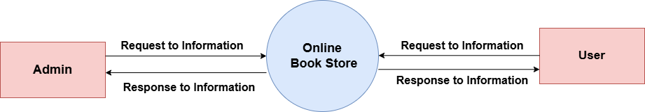

* **One level DFD**

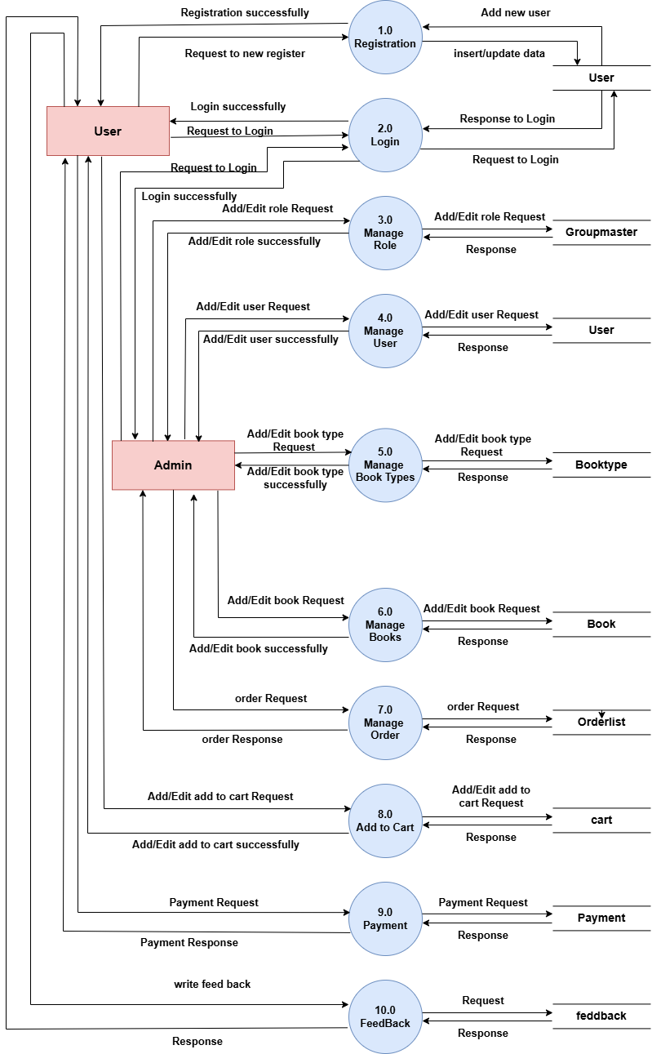

* **Admin 2 level Groupmaster**

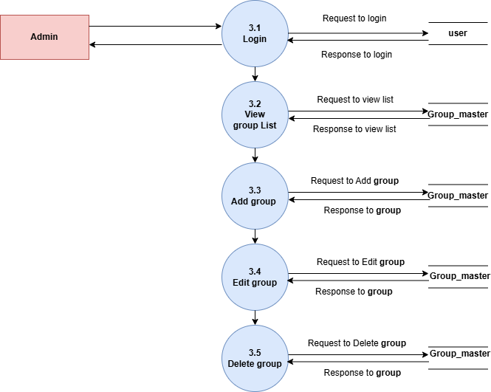

* **Admin : 2 level User Management**

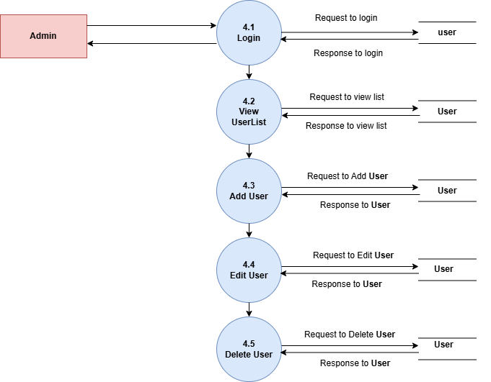

* **Admin : 2 level Book Type Management**

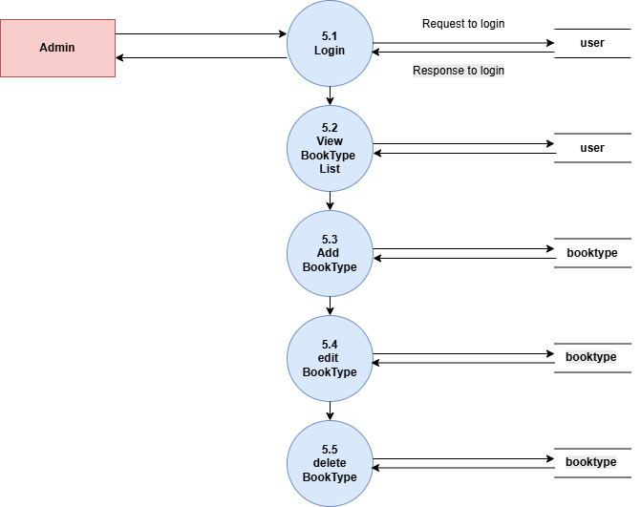

* **Admin : 2 level Books Management**

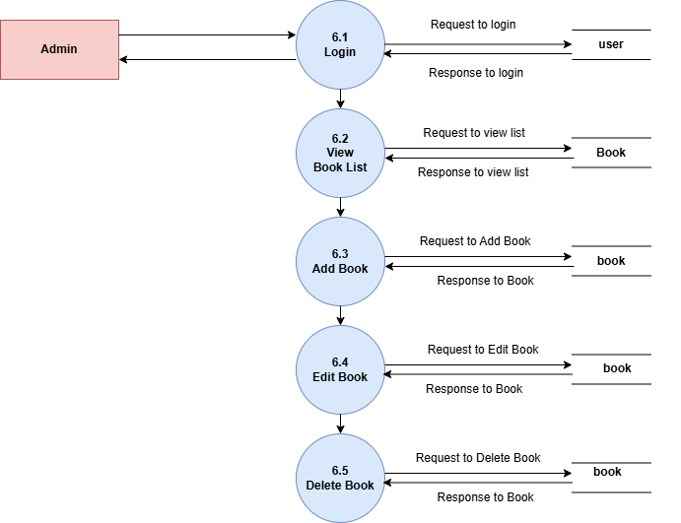

* **Admin : 2 level Order Management**

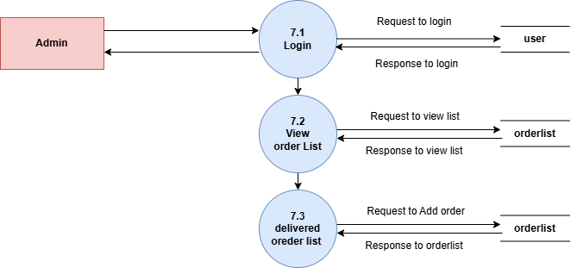

* **User: 2 level Add to cart Management**

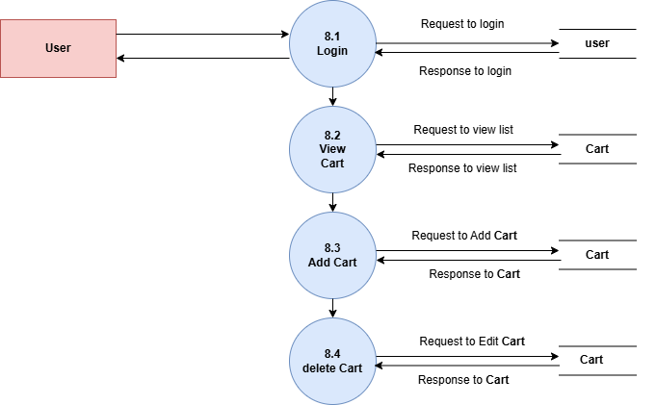

**5.2 UML Use Case Diagram**

* **Admin**

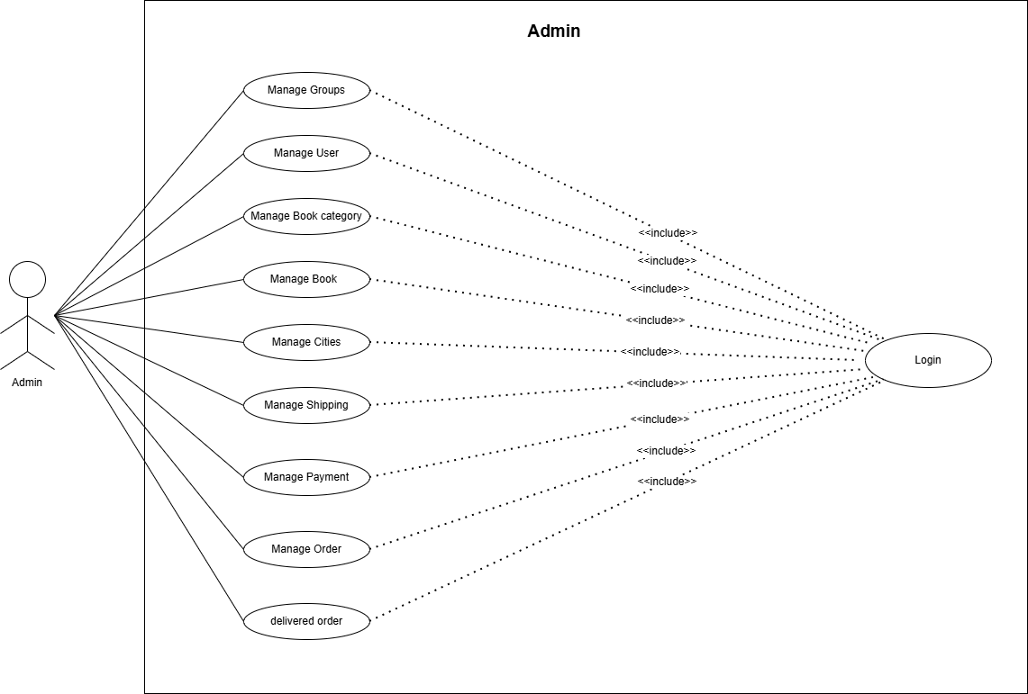

* **User**

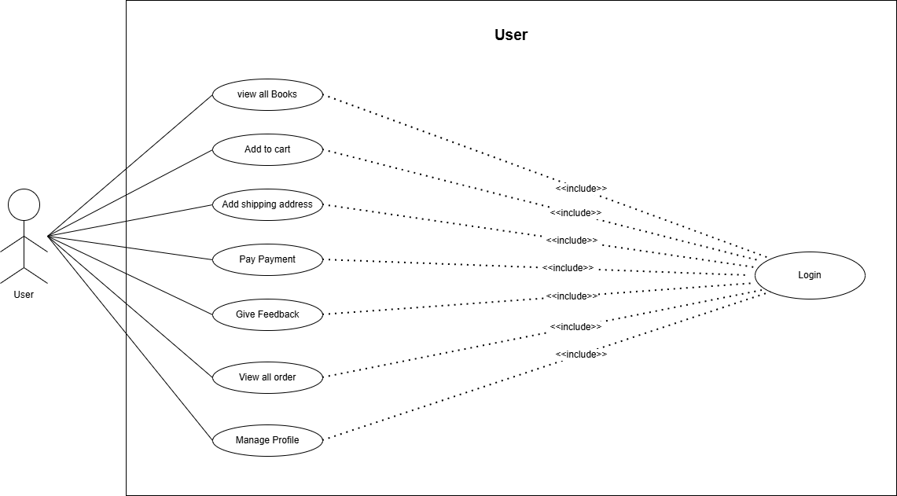

* 1. **UML Activity Diagram**
* **Admin**

* **User**

* 1. **Sequence Diagram**
* **Admin**

* **User**

* 1. **ER Diagram**

**5.6 Table Relation**

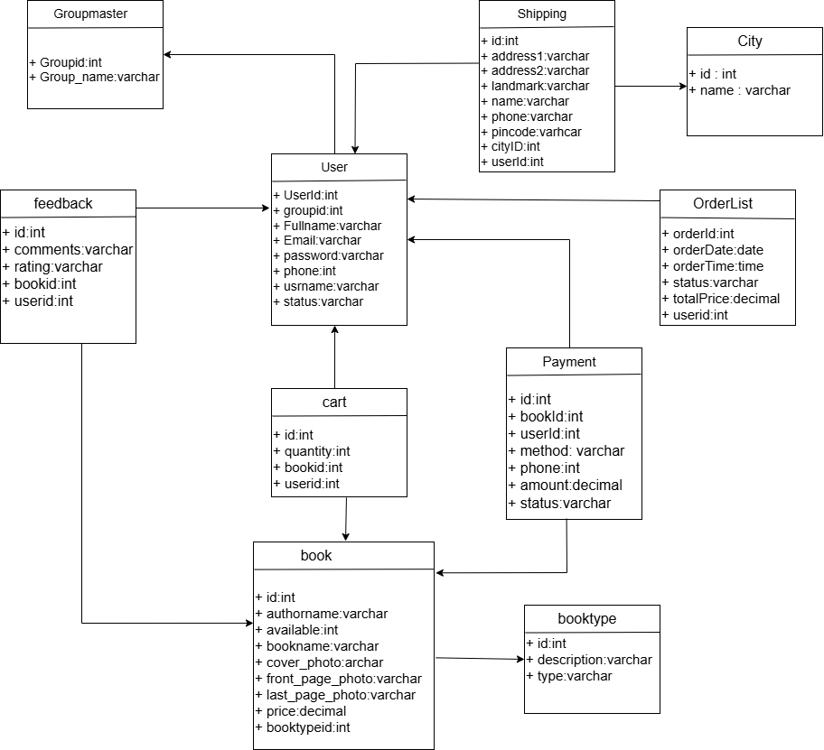

**5.7 Data Dictionary**

* **Group_master**

|  |  |  |  |
| --- | --- | --- | --- |
| **Column_name** | **Data Type** | **Key** | **Length** |
| Group_id | int | Primary key | - |
| Group_name | varchar | - | 255 |
| Name | varchar | - | 255 |

* **User:-**

|  |  |  |  |
| --- | --- | --- | --- |
| **Column_name** | **Data Type** | **Constrants** | **Length** |
| id | int | Primary key | - |
| Group_id | int | Foreign key | - |
| Fullname | varchar | - | 255 |
| phone | int | - | 15 |
| Username | varchar | - | 255 |
| Password | varchar | - | 255 |
| Email | varchar | - | 255 |
| Status | varchar | - | 255 |

* **BookType:-**

|  |  |  |  |
| --- | --- | --- | --- |
| **Column_name** | **Data Type** | **Constrants** | **Length** |
| id | int | Primary key | - |
| Type | varchar | - | 255 |
| Description | varchar | - | 255 |

* **Book**

|  |  |  |  |
| --- | --- | --- | --- |
| **Column_name** | **Data Type** | **Constrants** | **Length** |
| id | int | Primary key | - |
| BooktypeId | int | Foreign key | - |
| Bookname | varchar | - | 255 |
| Authorname | varchar | - | 255 |
| Price | decimal | - | 38,0 |
| Available | int | - | - |
| Cover_photo | varchar | - | 255 |
| front_page_photo | varchar | - | 255 |
| last_page_photo | varchar | - | 255 |

|  |  |  |  |
| --- | --- | --- | --- |
| **Column_name** | **Data Type** | **Constrants** | **Length** |
| id | int | Primary key | - |
| Userid | int | Foreign key | - |
| Bookid | int | Foreign key | - |
| Quantity | int | - | - |

* **Cart**
* **City**

|  |  |  |  |
| --- | --- | --- | --- |
| **Column_name** | **Data Type** | **Constrants** | **Length** |
| id | int | Primary key | - |
| Name | varchar |  | 255 |

* **Orderlist:-**

|  |  |  |  |
| --- | --- | --- | --- |
| **Column_name** | **Data Type** | **Constrants** | **Length** |
| OrderId | int | Primary key | - |
| UserId | int | Foreign key | - |
| bookId | int | Foreign key | - |
| paymentId | int | Foreign key | - |
| Time | time | - | - |
| date | date | - | - |
| Status | varchar | - | 255 |
| Total_price | decimal | - | 38,0 |

|  |  |  |  |
| --- | --- | --- | --- |
| **Column_name** | **Data Type** | **Constrants** | **Length** |
| id | int | Primary key | - |
| Userid | int | Foreign key | - |
| cityid | int | Foreign key | - |
| Name | varchar | - | 255 |
| phone | int | - | 10 |
| Address1 | varchar | - | 255 |
| Address2 | varchar | - | 255 |
| Landmark | vachar | - | 255 |
| Pincode | int | - | 10 |

* **Shipping**
* **Payment:-**

|  |  |  |  |
| --- | --- | --- | --- |
| **Column_name** | **Data Type** | **Constrants** | **Length** |
| id | int | Primary key | - |
| Bookid | int | Foreign key | - |
| Userid | int | Foreign key | - |
| Paymentmethod | varchar | - | 255 |
| Phone | int | - | 10 |
| Amount | decimal |  | 10,2 |
| Status | boolean | - | - |

* **Feedback**

|  |  |  |  |
| --- | --- | --- | --- |
| **Column_name** | **Data Type** | **Constrants** | **Length** |
| id | int | Primary key | - |
| Userid | int | Foreign key | - |
| Bookid | int | Foreign key | - |
| Rating | int | - | - |
| Comments | varchar | - | 255 |

6

**Interface Design**

* **Registration**

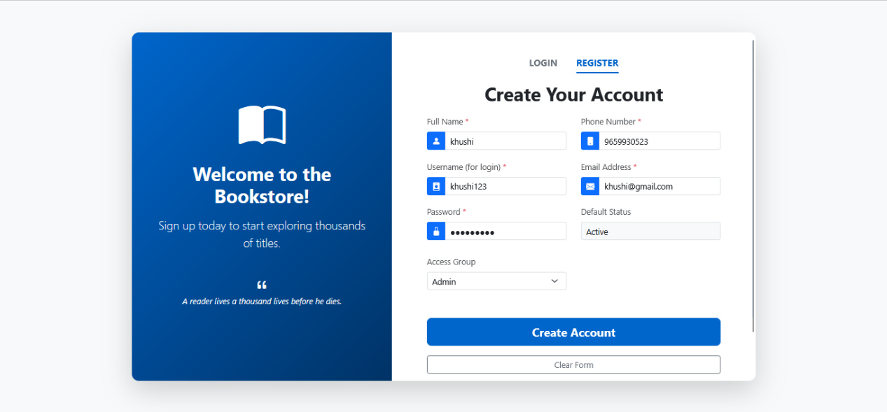

* **Login**

* **Admin : Dashboard**

* **Admin : Book Category**

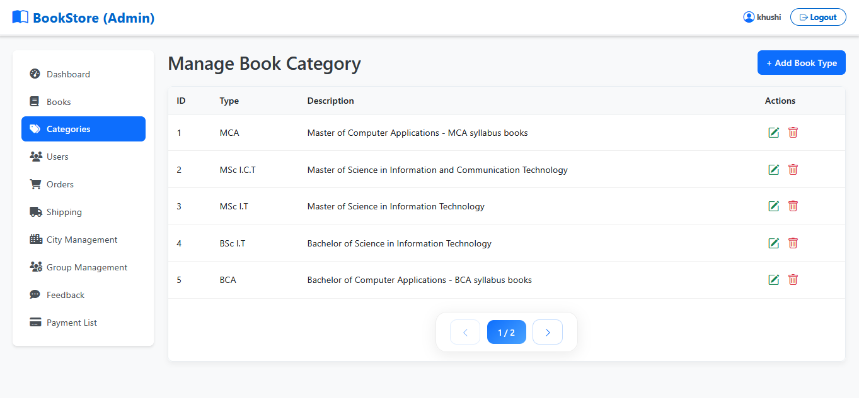

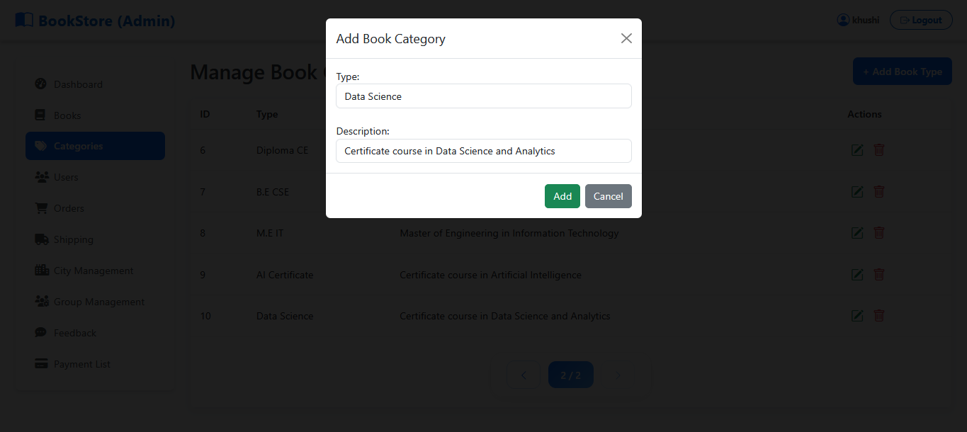

* **Admin : Book**

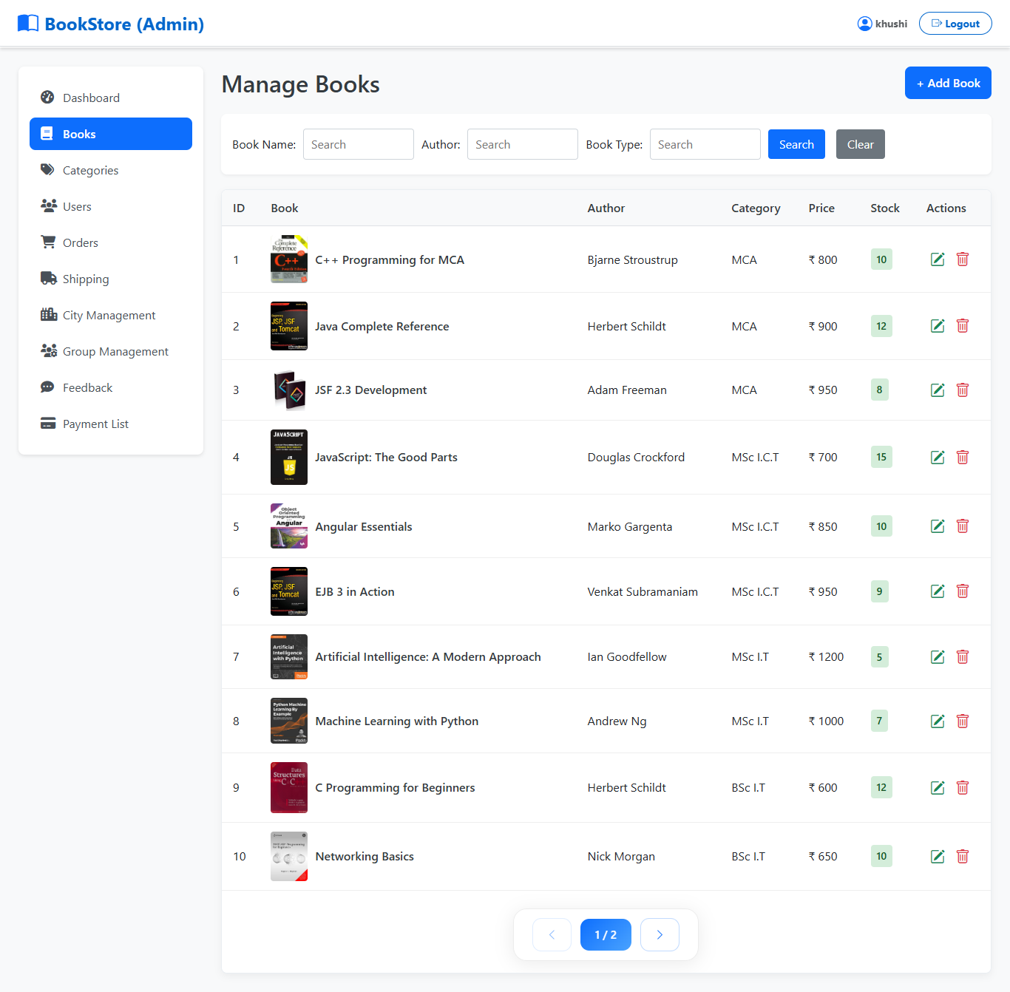

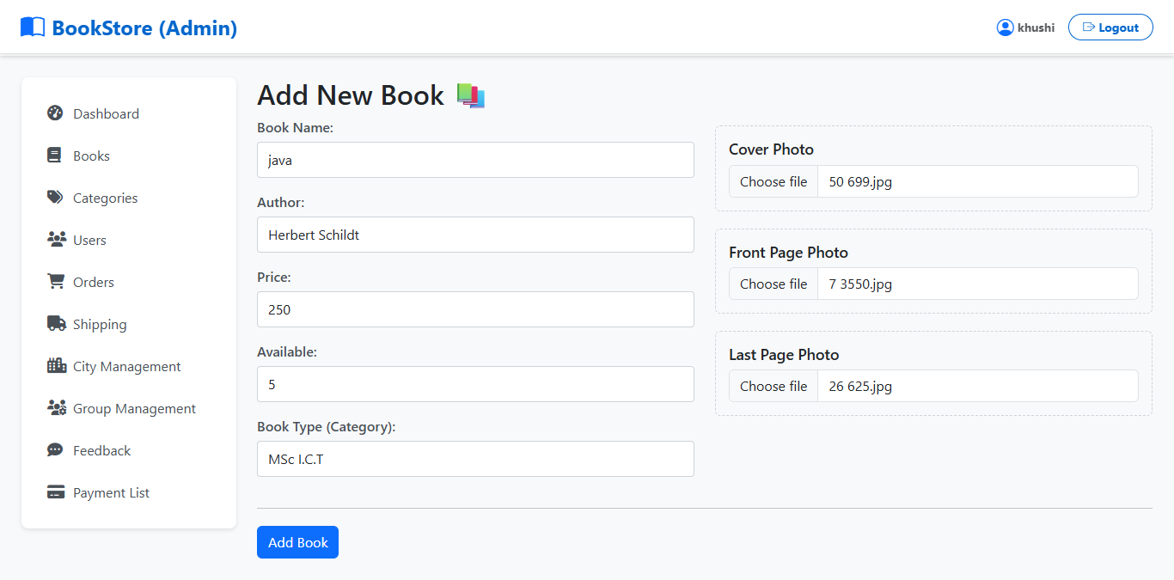

* **Admin : Order List**

* **Admin : User management**

* **Admin : Payment List**

* **User : DashBoard**



* **User : Book List**

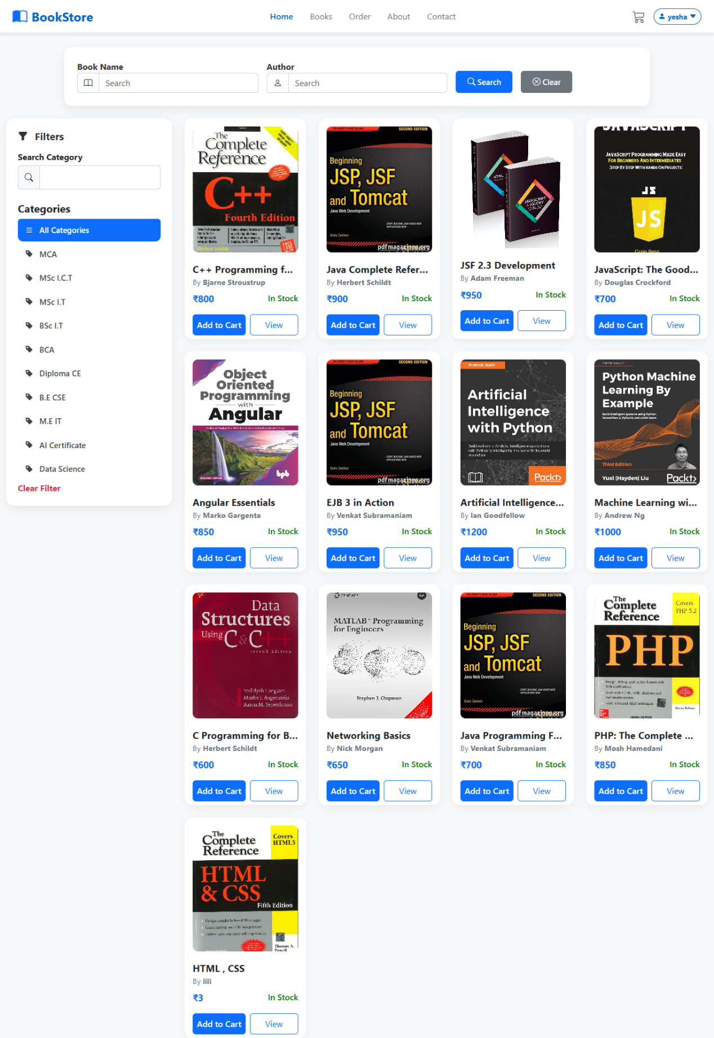

* **User : Cart List**

* **User : shipping Form**

* **User : Order List**

* **User : Invoice Print**

7

**System Testing**

**7. System Testing**

* **Login**

|  |  |  |  |  |  |  |
| --- | --- | --- | --- | --- | --- | --- |
| **Sr no** | **Description** | **Input value** | | **Expected Result** | **Actual Result** | **Paas/**  **Fail** |
|  |  | **usernam** | **password** |  |  |  |
| 1. | Check for validation | john123 | john | Redirect to admin dashboard | Redirect to  admin dashboard | Pass |
| 2. | Check for validation | John123 | Null | Error:password  is required. | Error:  password  is required. | Fail |
| 3. | Check for validation | Null | Null | Error:Both  required message | Error:Both  required message | Fail |

* **Registration**

|  |  |  |  |  |  |
| --- | --- | --- | --- | --- | --- |
| **Sr No.** | **Description** | **Input Values** | **Expected Result** | **Actual Result** | **Pass/Fail** |
| 1 | Check input detail validation | If all fields are filled properly and clicked on sign up button | Redirect to Login Page | Redirect to Login Page | Pass |
| 2 | Password validation | Check for password strength. Must contain 1 alphabet, 1 number and 1 special character | Enter Valid Password | Enter Valid Password | Fail |
| 3 | Email validation | Check for valid email. | Enter Valid Email | Enter Valid Email | Fail |
| 4 | Check for validation | If all details are not filled | Error: Please enter details | Error: Please enter details | Fail |

* **Book Type**

|  |  |  |  |  |  |
| --- | --- | --- | --- | --- | --- |
| **Sr No.** | **Description** | **Input Values** | **Expected Result** | **Actual Result** | **Pass/Fail** |
| 1 | Check input detail validation | If all fields are filled properly and clicked on save button | Redirect to Show Book type  List page | Redirect to Show Book type List Page | Pass |
| 2 | Book type name | If null book type name | Error : book type is required. | Error : book type is required. | Fail |
| 3 | Description | Check for Description | Enter Description | Enter Description | Pass |

* **Book**

|  |  |  |  |  |  |
| --- | --- | --- | --- | --- | --- |
| **Sr No.** | **Description** | **Input Values** | **Expected Result** | **Actual Result** | **Pass/Fail** |
| 1 | Check input detail validation | If all fields are filled properly and clicked on save button | Redirect to Show Book List page | Redirect to Show Book List Page | Pass |
| 2 | Bookname | If null book type name | Error : book name is required. | Error : book name is required. | Fail |
| 3 | authorname | Check for authorname | Enter authorname | Enter authorname | Pass |
| 4. | Price | Check if price in String | Error:enter only numbers | Error:enter only numbers | Fail |
| 5. | available | Check for stock of book |  |  |  |

8

**Future Enhancement**

**8. Future Enhancement**

* **Mobile Application Integration**   
  A dedicated Android/iOS mobile app can be developed so users can browse and purchase books conveniently from their smartphones.
* **Digital E-Book Support**   
  The system can be expanded to offer **e-books**, allowing customers to buy and read digital formats directly from the platform.
* **Multi-Language Support**   
  Adding support for multiple languages (English, Hindi, Tamil, etc.) will make the platform accessible to a wider audience.
* **Customer Chat Support / Chatbot**   
  A built-in AI chat assistant or helpdesk system can be added to provide instant customer support and resolve queries quickly.
* **Auto Email & SMS Alert System**   
  Notifications for order confirmation, shipping updates, out-of-stock alerts, and promotional messages can be automated.
* **Cloud Deployment**   
  Migrating the system to cloud platforms (AWS, Azure, Google Cloud) will ensure better scalability, performance, and reliability.
* **Author Panel (New Enhancement)**

A dedicated author panel can be introduced where authors can:

* Create and manage their own book listings
* Update book details and pricing
* View book sales statistics
* Respond to customer questions
* Upload new book editions or covers
* This will make the system more interactive and useful for authors and publishers.

9

**Glossary**

**9. Glossary**

The glossary explains the important words and terms used in this Online Bookstore System project. It helps readers understand both technical and non-technical terms that appear throughout the document. In this section, simple meanings are provided for common concepts like Admin, User Interface (UI), Database, Entity, REST API, JSF, EJB, Cart, Order, Category, and more. These explanations make it easier for anyone—whether they are students, developers, or general readers—to clearly understand how the system works. The glossary ensures that all readers can follow the project details without confusion and understand the functions, features, and technologies used in the online bookstore.

10

**References**